RPG Editor Tool

Design Document

Introduction to C# Assignment – A1DIP 2019

Academy of Interactive Entertainment

Thomas Maltezos

[thomasmaltezos00@gmail.com](mailto:thomasmaltezos00@gmail.com)

# **Summary**

This document contains all details regarding the RPG Editor Tool.

This tool will be used to create and edit characters and items that fit the genre of an RPG game. Users will be able to edit basic details such as item name and type while also being able to edit more advanced features such as in-game stats and appearance.

Users will be able to save their created characters and items to their machine and will also me able to edit previously created content.

# **Screen Mock-Ups**

## **Main Window**

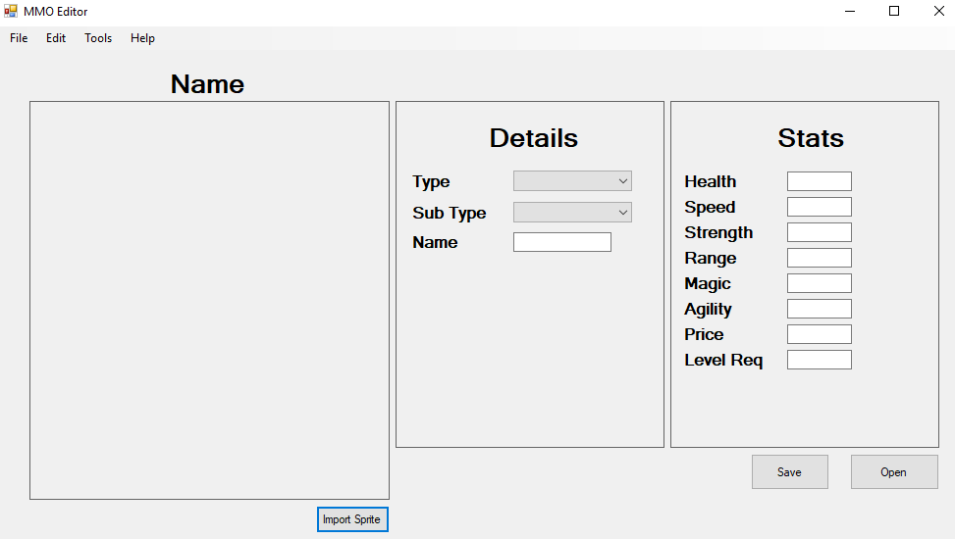Figure 1. Main interface.

As shown in Figure 1, text can be input into the white boxes and combo boxes for the type and sub types have been implemented. The types would include, ‘Item’ and ‘Character’ while the sub types would include, ‘Enemy’, ‘Neutral’, ‘Friendly’ and ‘Shop’ if the type was set to character. If the type is set to Item, the sub types would include, ‘Weapon’, ‘Tool’, ‘Ore’, ‘Wood’, ‘Currency’ and ‘Misc.’

The user can also press the Import Sprite button and select a sprite to assign to the character or item, the sprite will be shown on the left-hand side under the Name label. Once the user inputs text into the Name Textbox, the Name label above the picture box will change to the name specified.

## **Dialogues**

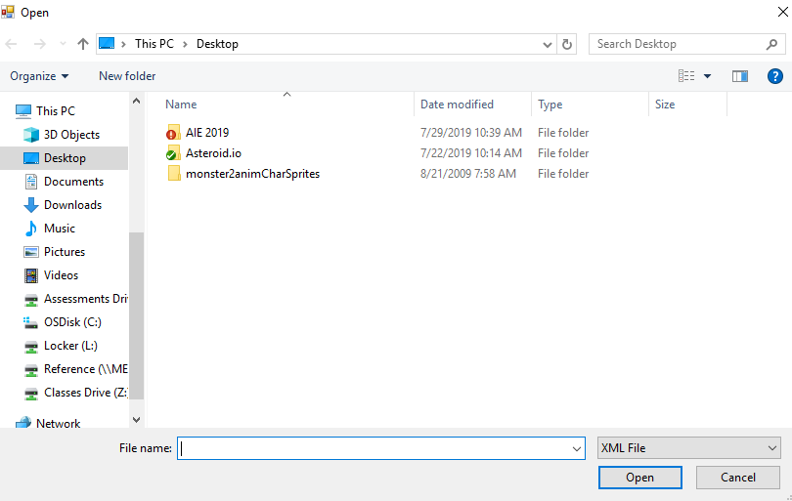Figure 2. Save dialogue box.

Figure 3. Open dialogue box.

As shown in Figure 2 and Figure 3, character and tool files will be saved and opened as XML files.